Roopali Reddy Kallem

Rxk180054

November 9, 2023

MIS 6380.001

Assignment 11

Q1)

Q2)

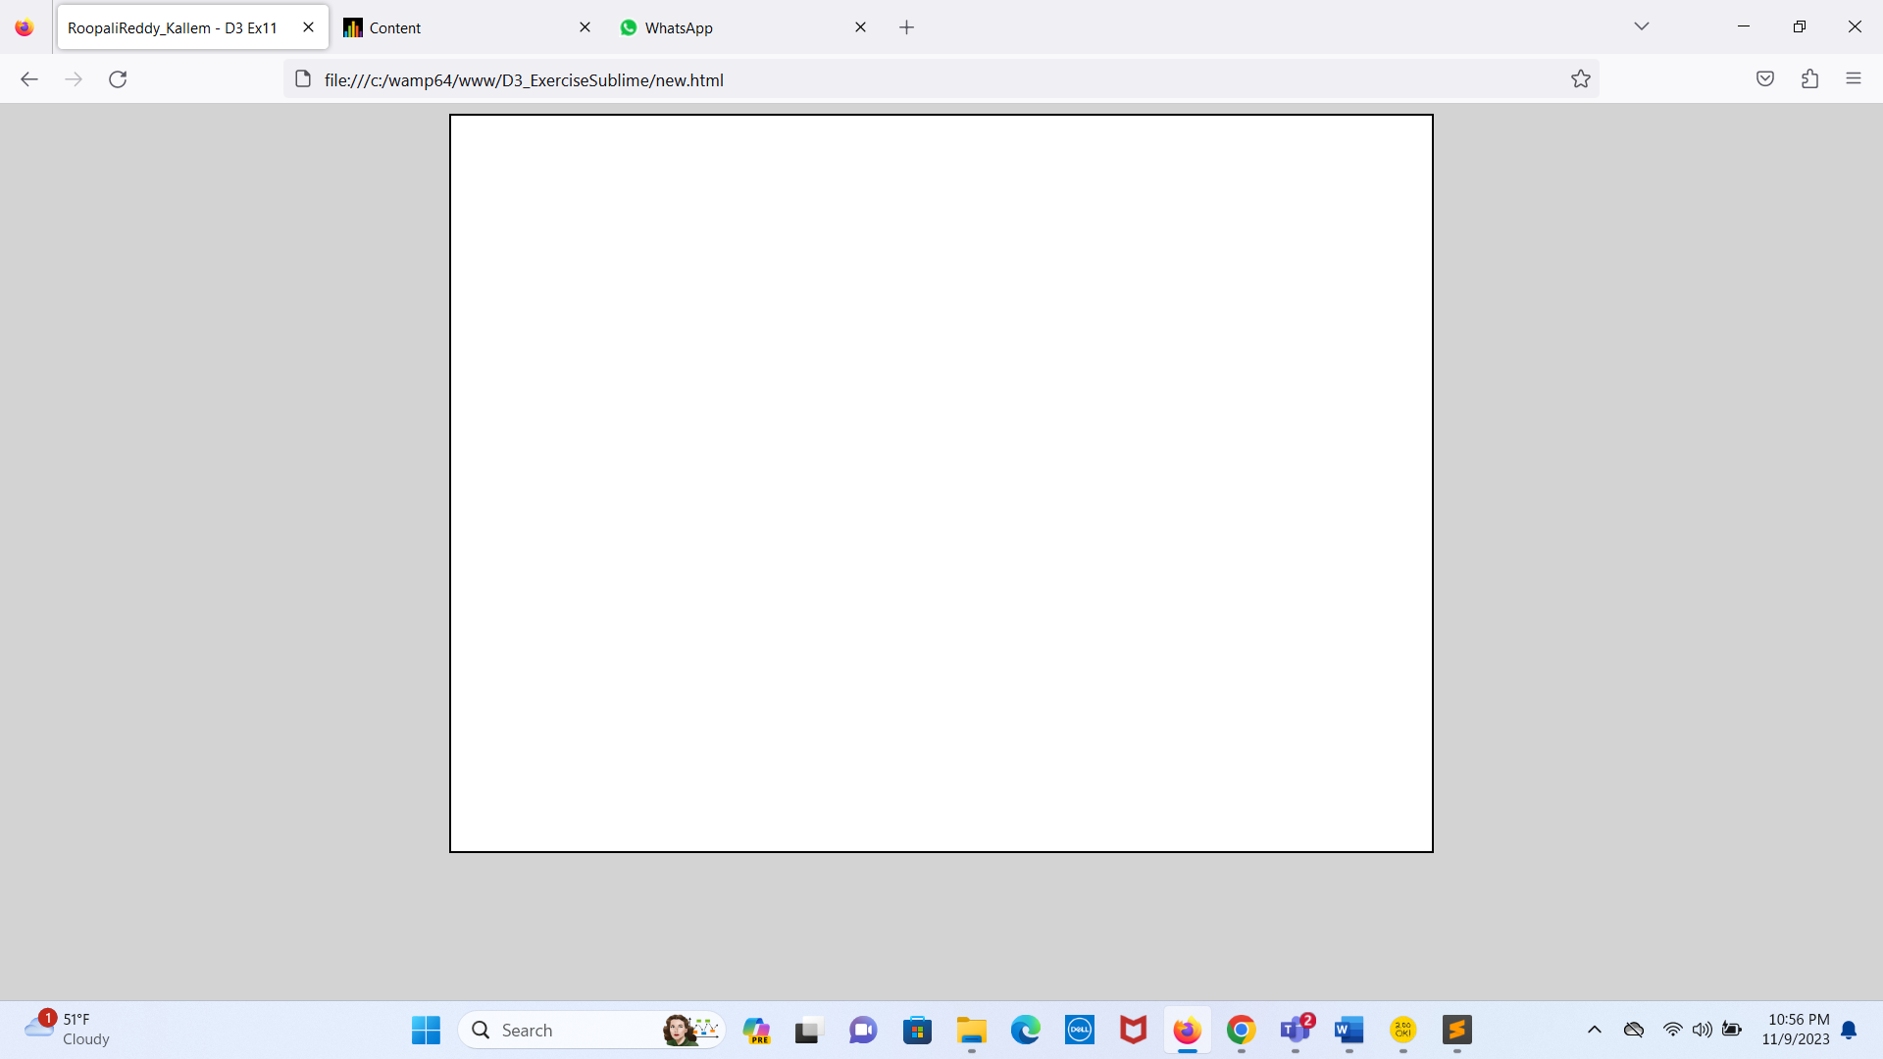

Q3)

Q4)

Q5)

Q6)

Q7)

Q8)

Q9)

Q10)

Q11)

Q12)

Q13)

Q14)

